

***WOW***

**E-Project Documentation**

**Teacher Name : Syeda Imama**

**APTECH COMPUTER EDUCATION**

**HYDERABAD-1 PAKISTAN**

**Issue Date : 03-dec-2023**

TABLE OF CONTENT

|  |  |  |
| --- | --- | --- |
| **S No** | **Contents** | **Page No** |
| 01 | Certificate | 3 |
| 02 | Acknowledgement | 4 |
| 03 | Project Report | 5 |
| 04 | Problem Definition | 6 |
| 05 | Customer Requirements Specification  (CRS) | 7 |
| 06 | Architecture Design of the Project | 9 |
| 07 | System Requirement | 10 |
| 08 | Task Sheet | 11 |
| 09 | Project Plan | 13 |
| 10 | Checklist of work Progress | 14 |
|  |  |  |
| 11 | Screen Shots | 15 |
| 12 | Source Code | 19 |

CERTIFICATE

This is to certify that

**MUBASHIR , SHAYAN,KHAYAM,SHAHWAIZ**

Has successfully Designed

WOW

Submitted by:

**MUBASHIR , SHAYAN,KHAYAM,SHAHWAIZ**

Date of Issue: 03-DEC-2023

**Authorized Signature:** Mam Syeda Imama

ACKNOWLEDGEMENT

First and foremost, we would like to express our deep gratitude and most heartfelt thanks to almighty ALLAH for his blessings, for lightening up our heart with the torch of knowledge and for giving us the ability to complete this project.

We would like to thanks Aptech Worldwide and the team of E-Project for their generous support and clarifying the doubts regarding e-project. We would like to acknowledge the way of explanation which the team of e-project gave in e-project to make website and we are equally grateful to our teacher (Sir Amjad Ali) for giving us a moral support and guiding us different matters regarding project in all the time about the research and writing of this project.

We are greatly indebted to Aptech Worldwide, Sir Amjad Ali, Faculty Members and ACE Hyderabad, Pakistan for encouragement and incessant help.

PROJECT REPORT

**Project Title : WOW,**

**Members Name : Mubashir, shayan,khayam,shahwaiz**

**Batch Code : 2307E**

**Start Date : 03- dec-2023**

**End Date : 27-dec-2023**

**Course : ACCP (CPISM)**

**Teacher : mam Imama**

**Center Manager : sir shuaib**

**Center Academic Head : sir zubair**

**Center Name : ACE Hyderabad-1, Pakistan**

Submitted as

E Project Documentation

**PROBLEM STATEMENT**

Wonders of World (WOW) website will present the information about the various

wonders. The information behind this creature must be added. The information of

historic places can be categorized. The link of seven wonders, Gallery section,

Contact Us, Feedback and Site Map must be added

The website is to be developed for the Windows Platform using HTML5, JavaScript

and Geolocation. The site should work well in all leading browsers including Chrome,

IE, Firefox etc.

**Requirement Specification**

The Web site is to be created based on the following requirements.

1) The Home Page should be created making use of Sections with a suitable

logo, the header section can be added which will show different famous

images of respective wonders.

2) The site must contain the links to navigate through any zone for the

information.

3) History behind all the wonder monuments can be added along with the

images.

4) Gallery section can be added for viewing different images.

5) Feedback must be allowed to enter by the viewer

6) Site map, Gallery, about us, Queries link, Contact us link must be added.

7) The complete historic reason and its description must be allowed to get

download as pdf or doc file.

8) The advertise section of bus, flights can be included for reaching the places.

PROJECT OBJECTIVE:

The Objective of this program is to give a sample project to work on real life

projects. These applications help you build a larger more robust application.

The objective is not to teach you HTML/JavaScript/Dreamweaver/HTML5 but to

provide you with a real life scenario and help you create basic applications using the

tools.

You can revise the chapters before you start with the project.

This project is meant for students who have completed the module of

Dreamweaver. These programs should be done in the Lab sessions with assistance

of the faculty if required.

It is very essential that a student has a clear understanding of the subject. Students

should go through the project and solve the assignments as per requirements given.

Kindly get back to eProjects Team in case of any doubts regarding the application or

its objectives.

Architecture & Design of the Project:

Since the website will have client server architecture it will have one-tier architecture.

Hardware/ Software Requirements

Hardware

* A minimum computer system that will help you access all the tools in the courses is a Pentium 166 or better
* 64 Megabytes of RAM or better

Software [Either or Combination as per Course/Sem]

• Notepad/HTML editor/CoffeeCup

• Angular / Angular JS / React / BootStrap

• Dreamweaver / Figma

• MS IE / Chrome / FireFox / Netscape /MS Edge

TASK SHEET

|  |  |  |  |  |  |
| --- | --- | --- | --- | --- | --- |
| **Project Ref. No:** | | **Date of Preparation of Activity Plan:** | | | |
| SR.  No | Task | Actual  Start  Date: | Actual  Day: | Team  Mates  Names: | Status: |
| 01 | Planing | 03-dec-2023 | 1 | SHAYAN | YES |
| 02 | Data  Collection | 05-DEC-2023 | 1 | MUBASHIR | YES |
| 03 | Designing  Home  Page | 10-DEC-2023 | 4 | MUBASHIR | YES |
| 04 | Linking | 12-DEC-2023 | 9 | SHAYAN | YES |
| 05 | Check  Links | 18-DEC-2023 | 2 | MUBASHIR | YES |
| 06 | Finalizing | 20-DEC-2023 | 3 | KHAYAM | YES |
| 07 | Testing | 23-DEC-2023 | 2 | KHAYAM | YES |
| 08 | Documentation | 26-DEC-2023 | 1 | SHAHWAIZ | YES |
| 09 | Uploading | 27-DEC-2023 | 2 | SHAHWAIZ | YES |

PROJECT PLAN

* Website is able to execute quickly.
* The color scheme of the site looks attractive.
* The collection of data is authentic and taken by the most popular product websites.
* There is authentic information of facilities products with their specifications.
* Background is different to main page.
* The HOME is well prepared exactly for the same page as user clicks on the link..
* A visitor can also view the individual image of our every gallery.

CHECK LIST OF WORK PROGRESS

|  |  |  |
| --- | --- | --- |
| **SR.No** | **Aspect Tested** | **Remarks** |
| 01 | Data Collection | **yes** |
| 02 | Designing Home Page | **yes** |
| 05 | Linking The Pages | **yes** |
| 06 | Finalization | **Yes** |
| 08 | Tasting The Site | **Yes** |
| 09 | Documentation | **yes** |

SCREEN SHOTS

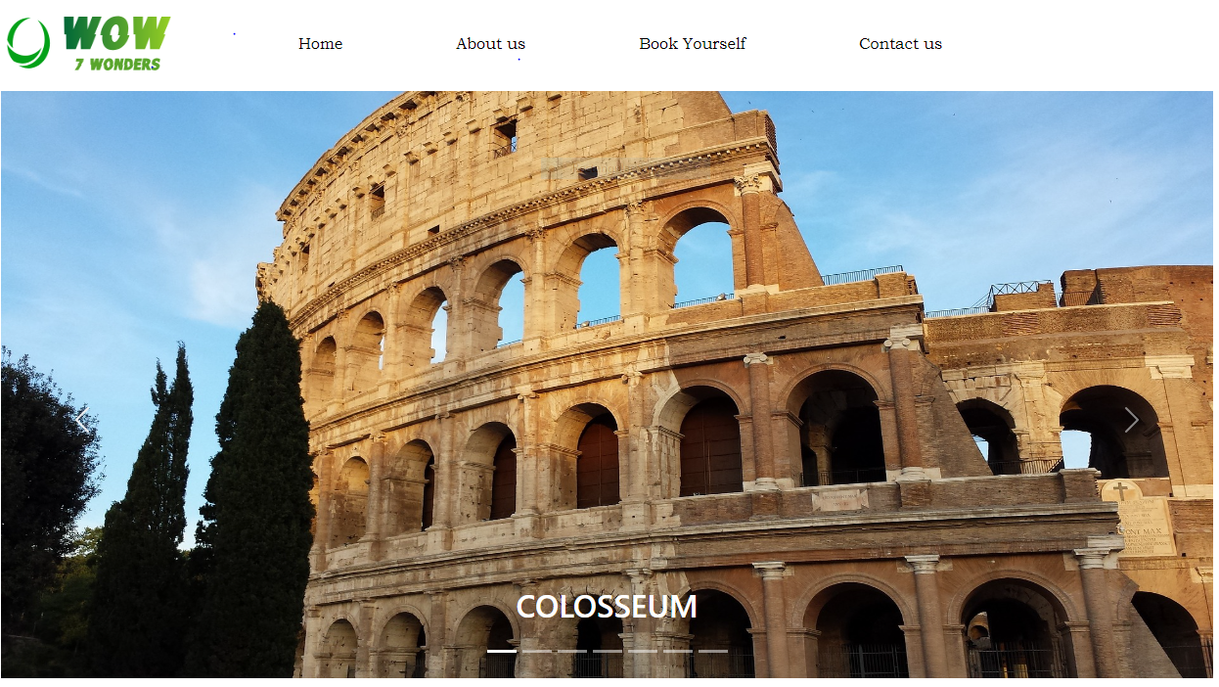Home-page-1

Home-page-2

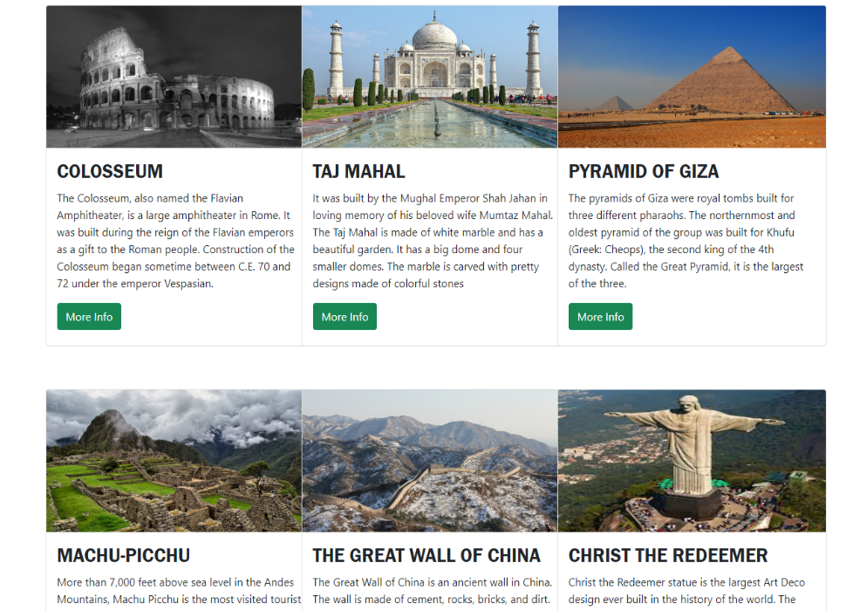

Home-page-3

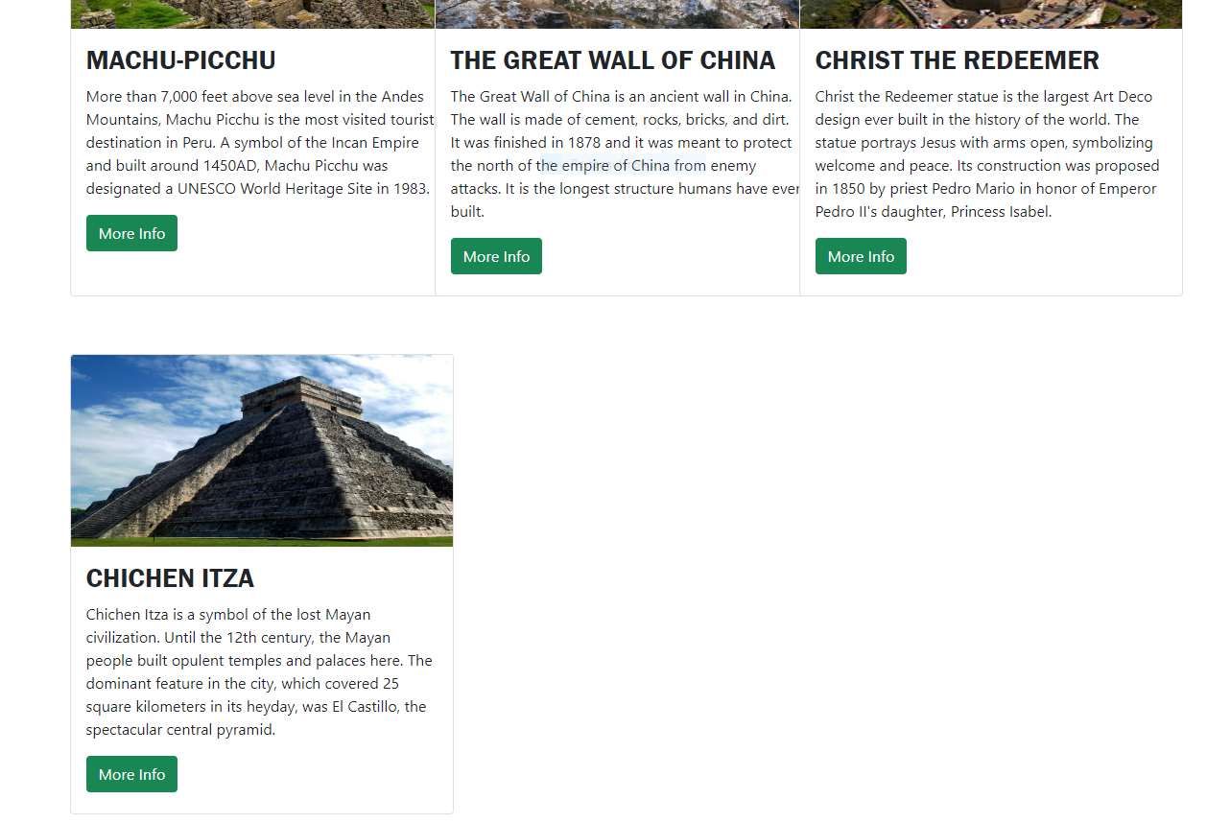

Home-page-4

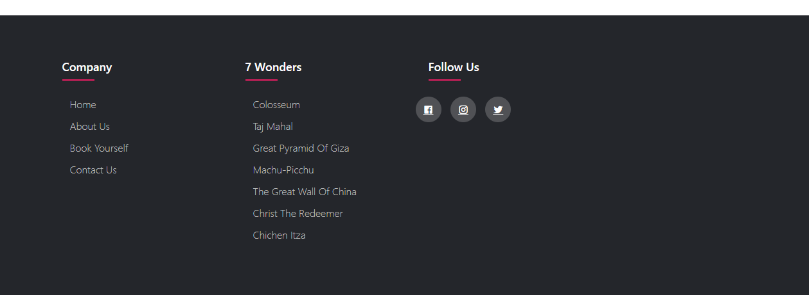

About us

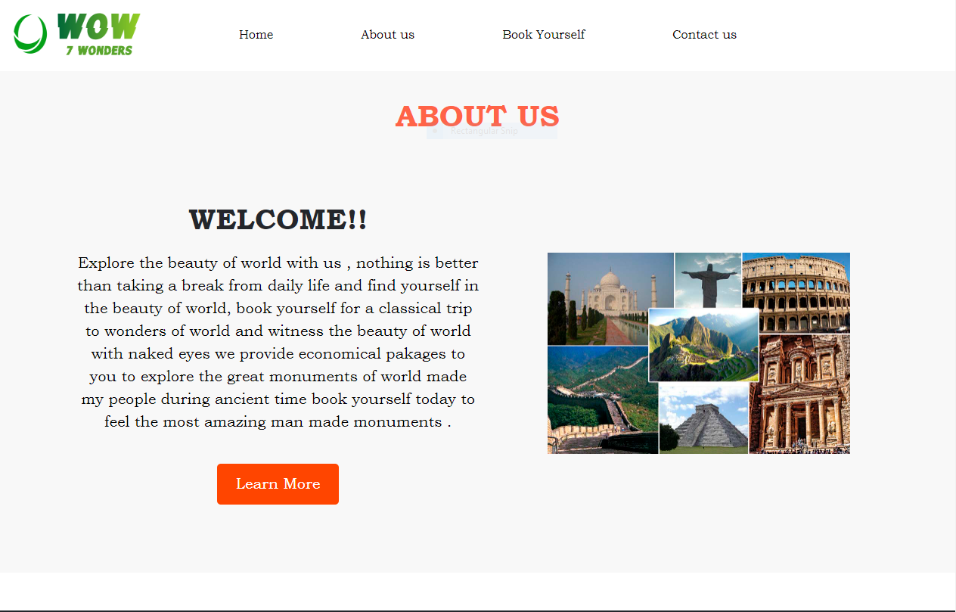

Booking-page

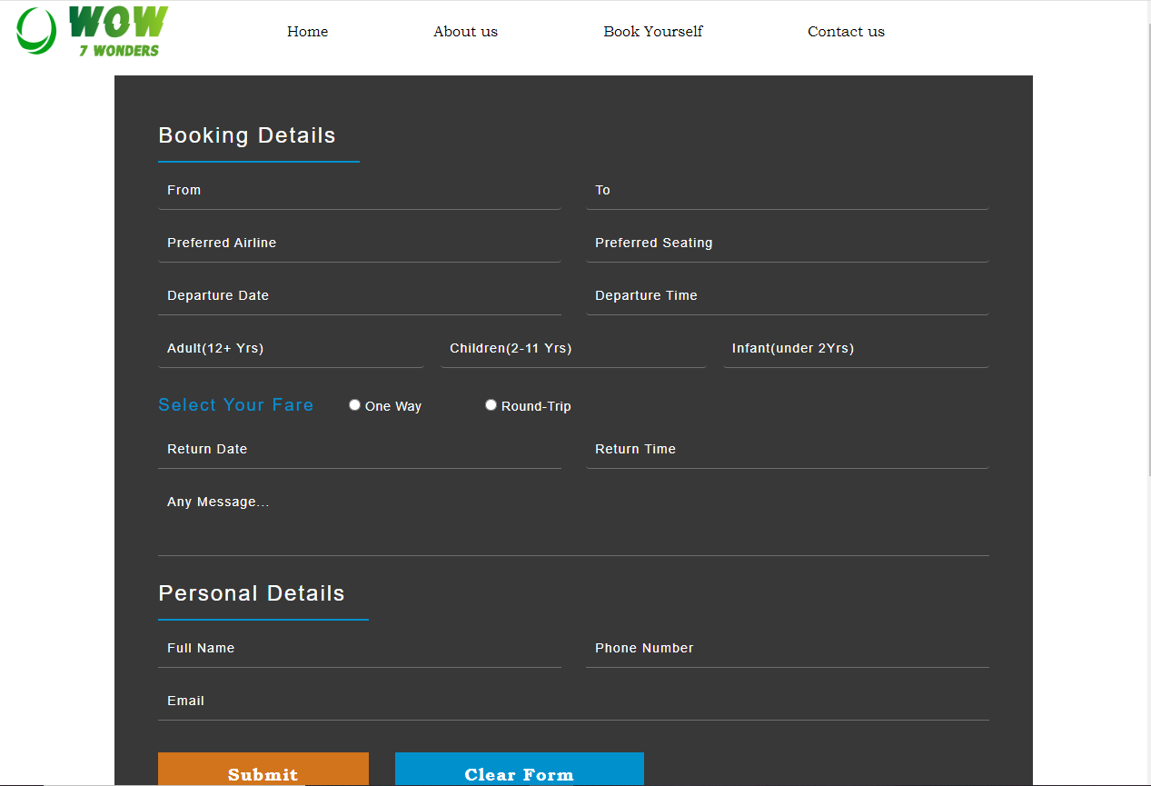

Contact-us

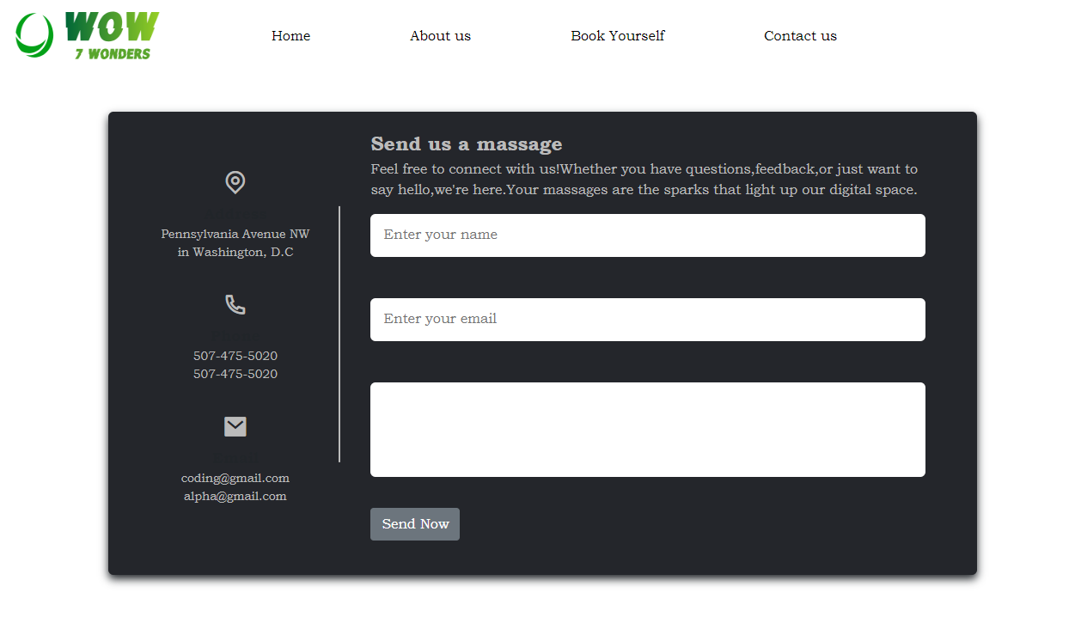

SOURCE CODE

   <!DOCTYPE html>

<html lang="en">

<head>

    <meta charset="UTF-8">

    <meta name="viewport" content="width=device-width, initial-scale=1.0">

    <title>WoW.com</title>

    <link rel="stylesheet" href="bootstrap-5.1.3-dist\css\bootstrap.min.css">

    <script src="jquery-3.7.1.min.js"></script>

    <link

    href="https://cdn.jsdelivr.net/npm/remixicon@4.0.0/fonts/remixicon.css"

    rel="stylesheet"

/>

    <style>

     .navbar{

      background-color: #24262b;

     }

        .card{

          margin-top:60px ;

        }

       .nav-link{

            margin-left: 100px;

            color:rgb(0, 0, 0);

            font-family: Bookman Old Style;;

       }

       .nav-link:hover{

        color: goldenrod;

       }

        .card-text{

         transition: 2s;

         transition: duration 3s;;

        }

      *{

        box-sizing: border-box;

      }

      .item{

           max-width: 1170px;

           background-color: red;

           margin-top: auto;

      }

      ul{

        list-style: none;

      }

      .footer{

        background-color: #24262b;

        padding: 70px 0;

        margin-top: 50px;

      }

      .footer-col{

        width: 25%;

        padding: 0 15px;

      }

      .footer-col h4{

        font-size: 18px;

        color: white;

        text-transform: capitalize;

        margin-bottom: 35px;

        font-weight: 500;

        position: relative;

        margin-left: 20px;

      }

      .footer-col h4::before{

        content: '';

        position: absolute;

        left: 0;

        bottom: -10px;

        background-color: #e91e63;

        height: 2px;

        box-sizing: border-box;

        width: 50px;

      }

      .footer-col ul li:not(:last-child){

          margin-bottom: 10px;

      }

      .footer-col ul li a{

        font-size: 16px;

        text-transform:capitalize;

        color: white;

        text-decoration: none;

        font-weight: 300;

        color: #bbbbbb;

        display: block;

        transition: all 0.3 ease;

      }

      .footer-col ul li a:hover{

        color: white;

        padding: 3px;

      }

      .footer-col .socail-links a{

        display: inline-block;

        height: 40px;

        width: 40px;

        background-color: rgb(255, 255, 255 , 0.2);

        margin:0 10px 10px 0;

        text-align: center;

        line-height: 40px;

        border-radius: 50%;

        color: #ffffff;

        transform: all 0.5s ease;

      }

      .footer-col .socail-links a:hover{

        color: #24262b;

        background-color: #ffffff;

      }

      @media(max-width: 767px){

        .footer-col{

          width: 25%;

          margin-bottom: 30px;

        }

      }

      @media(max-width: 574px){

        .footer-col{

          width: 100%;

        }

      }

    </style>

</head>

<body>

    <nav class="navbar navbar-expand-lg navbar-white bg-white">

        <div class="container-fluid">

          <a class="navbar-brand" href="#"><img src="images\Capture.PNG2.PNG" width="180px" height="70px"></a>

          <button class="navbar-toggler" type="button" data-bs-toggle="collapse" data-bs-target="#navbarSupportedContent" aria-controls="navbarSupportedContent" aria-expanded="false" aria-label="Toggle navigation">

            <span class="navbar-toggler-icon"></span>

          </button>

          <div class="collapse navbar-collapse" id="navbarSupportedContent">

            <ul class="navbar-nav me-auto mb-2 mb-lg-0">

              <li class="nav-item">

                <a class="nav-link active" aria-current="page" href="index.html">Home</a>

              </li>

              <li class="nav-item">

                <a class="nav-link" href="aboutus.html">About us</a>

              </li>

              <li class="nav-item ">

                <a class="nav-link " href="bookyourself.html" id="navbarDropdown" role="button" >

                Book Yourself

                </a>

              </li>

              <li class="nav-item">

                <a class="nav-link" href="contactus.html" tabindex="-1" aria-disabled="false">Contact us</a>

              </li>

            </ul>

          </div>

        </div>

      </nav>

       <div class="container-fluid">

        <div class="row">

          <div class="col-lg-12 col-md-12 col-sm-12">

       <div id="carouselExampleCaptions" class="carousel slide" data-bs-ride="carousel">

        <div class="carousel-indicators">

          <button type="button" data-bs-target="#carouselExampleCaptions" data-bs-slide-to="0" class="active" aria-current="true" aria-label="Slide 1"></button>

          <button type="button" data-bs-target="#carouselExampleCaptions" data-bs-slide-to="1" aria-label="Slide 2"></button>

          <button type="button" data-bs-target="#carouselExampleCaptions" data-bs-slide-to="2" aria-label="Slide 3"></button>

          <button type="button" data-bs-target="#carouselExampleCaptions" data-bs-slide-to="3" aria-label="Slide 4"></button>

          <button type="button" data-bs-target="#carouselExampleCaptions" data-bs-slide-to="4" aria-label="Slide 5"></button>

          <button type="button" data-bs-target="#carouselExampleCaptions" data-bs-slide-to="5" aria-label="Slide 6"></button>

          <button type="button" data-bs-target="#carouselExampleCaptions" data-bs-slide-to="6" aria-label="Slide 7"></button>

        </div>

        <div class="carousel-inner">

          <div class="carousel-item active">

            <img src="images\colloseum-2914216_1920.jpg" class="d-block w-100" alt="..." height="600px">

            <div class="carousel-caption d-none d-md-block">

              <h2>COLOSSEUM</h2>

              <p></p>

            </div>

          </div>

          <div class="carousel-item">

            <img src="images/taj-mahal-1009262_1920.jpg" class="d-block w-100" alt="..." height="600px">

            <div class="carousel-caption d-none d-md-block">

              <h2>TAJ MAHAL</h2>

              <p></p>

            </div>

          </div>

          <div class="carousel-item">

            <img src="images\landscape-5584652_1920.jpg" class="d-block w-100" alt="..." height="600px">

            <div class="carousel-caption d-none d-md-block">

              <h2>PYRAMID OF GIZA</h2>

              <p></p>

            </div>

          </div>

          <div class="carousel-item">

            <img src="images\machu-picchu-588634_1920.jpg" class="d-block w-100" alt="..." height="600px">

            <div class="carousel-caption d-none d-md-block">

              <h2>MACHU-PICCHU </h2>

              <p></p>

            </div>

          </div>

          <div class="carousel-item">

            <img src="images/great-wall-of-china-804886_1920 (1).jpg" class="d-block w-100" alt="..." height="600px">

            <div class="carousel-caption d-none d-md-block">

              <h2>THE GREAT WALL OF CHINA</h2>

              <p></p>

            </div>

          </div>

          <div class="carousel-item">

            <img src="images\pyramid-2826190_1920.jpg" class="d-block w-100" alt="..." height="600px">

            <div class="carousel-caption d-none d-md-block">

              <h2>CHICHEN ITZA</h2>

              <p> </p>

            </div>

          </div>

          <div class="carousel-item">

            <img src="images\statue-518001_1920.jpg" class="d-block w-100" alt="..." height="600px">

            <div class="carousel-caption d-none d-md-block">

              <h2>CHRIST THE REDEEMER</h2>

              <p></p>

            </div>

          </div>

        </div>

        </div>

        </div>

      </div>

        <button class="carousel-control-prev" type="button" data-bs-target="#carouselExampleCaptions" data-bs-slide="prev">

          <span class="carousel-control-prev-icon" aria-hidden="true"></span>

          <span class="visually-hidden">Previous</span>

        </button>

        <button class="carousel-control-next" type="button" data-bs-target="#carouselExampleCaptions" data-bs-slide="next">

          <span class="carousel-control-next-icon" aria-hidden="true"></span>

          <span class="visually-hidden">Next</span>

        </button>

      </div>

    <div class="container">

      <div class="row">

        <div class=" col-lg-4 col-md-6" id="set1">

          <div class="card" style="width: 25rem;  height: 480px;">

            <img src="images\colloseum-116009_1920.jpg" class="card-img-top" alt="..." height="200px">

            <div class="card-body">

              <h3 class="card-title" style="font-family: 'Franklin Gothic Medium', 'Arial Narrow', Arial, sans-serif;">COLOSSEUM</h3>

              <p class="card-text">The Colosseum, also named the Flavian Amphitheater, is a large amphitheater in Rome. It was built during the reign of the Flavian emperors as a gift to the Roman people. Construction of the Colosseum began sometime between C.E. 70 and 72 under the emperor Vespasian.</p>

              <a href="colosseum.html" class="btn btn-success" >More Info</a>

            </div>

          </div>

        </div>

        <div class="col-lg-4 col-md-6" id="set">

          <div class="card" style="width: 25rem;  height: 480px;" >

            <img src="images\india-3578009_1920.jpg" class="card-img-top" alt="..." height="200px">

            <div class="card-body">

              <h3 class="card-title" style="font-family: 'Franklin Gothic Medium', 'Arial Narrow', Arial, sans-serif;">TAJ MAHAL</h3>

              <p class="card-text">It was built by the Mughal Emperor Shah Jahan in loving memory of his beloved wife Mumtaz Mahal. The Taj Mahal is made of white marble and has a beautiful garden. It has a big dome and four smaller domes. The marble is carved with pretty designs made of colorful stones</p>

              <a href="tajmahal.html" class="btn btn-success" >More Info</a>

            </div>

          </div>

        </div>

        <div class="col-lg-4 " id="set1">

          <div class="card" style="width: 25rem; height: 480px;" >

            <img src="images\egypt-1002916_1920.jpg" class="card-img-top" alt="..." height="200px">

            <div class="card-body">

              <h3 class="card-title" style="font-family: 'Franklin Gothic Medium', 'Arial Narrow', Arial, sans-serif;">PYRAMID OF GIZA</h3>

              <p class="card-text">The pyramids of Giza were royal tombs built for three different pharaohs. The northernmost and oldest pyramid of the group was built for Khufu (Greek: Cheops), the second king of the 4th dynasty. Called the Great Pyramid, it is the largest of the three.</p>

              <a href="pyramid.html" class="btn btn-success">More Info</a>

            </div>

          </div>

        </div>

      </div>

      <div class="row">

        <div class="col-lg-4 col-md-6" id="set">

          <div class="card" style="width: 25rem;  height: 480px;" >

            <img src="images\machupicchu-1138641_1920.jpg" class="card-img-top" alt="..." height="200px">

            <div class="card-body">

              <h3 class="card-title" style="font-family: 'Franklin Gothic Medium', 'Arial Narrow', Arial, sans-serif;">MACHU-PICCHU</h3>

              <p class="card-text">More than 7,000 feet above sea level in the Andes Mountains, Machu Picchu is the most visited tourist destination in Peru. A symbol of the Incan Empire and built around 1450AD, Machu Picchu was designated a UNESCO World Heritage Site in 1983.</p>

              <a href="machu-picchu.html" class="btn btn-success">More Info</a>

            </div>

          </div>

        </div>

    <div class="col-lg-4 col-md-6" id="set1">

      <div class="card" style="width: 25rem;  height: 480px;">

        <img src="images\china-2091360_1920.jpg" class="card-img-top" alt="..."  height="200px">

        <div class="card-body">

          <h3 class="card-title" style="font-family: 'Franklin Gothic Medium', 'Arial Narrow', Arial, sans-serif;">THE GREAT WALL OF CHINA</h3>

          <p class="card-text">The Great Wall of China is an ancient wall in China. The wall is made of cement, rocks, bricks, and dirt. It was finished in 1878 and it was meant to protect the north of the empire of China from enemy attacks. It is the longest structure humans have ever built.</p>

          <a href="wallofchina.html" class="btn btn-success">More Info</a>

        </div>

      </div>

    </div>

    <div class="col-lg-4 col-md-6" id="set">

      <div class="card" style="width: 25rem;  height: 480px;">

        <img src="images\download.jpg" class="card-img-top" alt="..." height="200px">

        <div class="card-body">

          <h3 class="card-title" style="font-family: 'Franklin Gothic Medium', 'Arial Narrow', Arial, sans-serif;">CHRIST THE REDEEMER</h3>

          <p class="card-text">Christ the Redeemer statue is the largest Art Deco design ever built in the history of the world. The statue portrays Jesus with arms open, symbolizing welcome and peace. Its construction was proposed in 1850 by priest Pedro Mario in honor of Emperor Pedro II's daughter, Princess Isabel.</p>

          <a href="christredeemer.html" class="btn btn-success">More Info</a>

        </div>

      </div>

    </div>

   </div>

   <div class="row">

    <div class="col-lg-12 col-md-12" id="set2">

      <div class="card" style="width: 25rem; height: 480px;" >

        <img src="images\mexico-1032966_1920.jpg" class="card-img-top" alt="..." height="200px">

        <div class="card-body">

          <h3 class="card-title" style="font-family: 'Franklin Gothic Medium', 'Arial Narrow', Arial, sans-serif;">CHICHEN ITZA</h3>

          <p class="card-text">Chichen Itza is a symbol of the lost Mayan civilization. Until the 12th century, the Mayan people built opulent temples and palaces here. The dominant feature in the city, which covered 25 square kilometers in its heyday, was El Castillo, the spectacular central pyramid.</p>

          <a href="chichenitza.html" class="btn btn-success">More Info</a>

        </div>

      </div>

    </div>

   </div>

  </div>

<footer class="footer">

  <div class="container" id="item">

    <div class="row">

      <div class="footer-col">

        <h4>Company</h4>

        <ul>

          <li><a href="index.html">Home</a></li>

          <li><a href="aboutus.html">About us</a></li>

          <li><a href="bookyourself.html">Book yourself</a></li>

          <li><a href="contactus.html">Contact us</a></li>

        </ul>

      </div>

      <div class="footer-col">

        <h4>7 Wonders</h4>

        <ul>

          <li><a href="colosseum.html">Colosseum</a></li>

          <li><a href="tajmahal.html">Taj Mahal</a></li>

          <li><a href="pyramid.html">Great pyramid of giza</a></li>

          <li><a href="machu-picchu.html">Machu-Picchu</a></li>

          <li><a href="wallofchina.html">The great wall of china</a></li>

          <li><a href="christredeemer.html">Christ the redeemer</a></li>

          <li><a href="chichenitza.html">Chichen itza</a></li>

        </ul>

      </div>

      <div class="footer-col">

        <h4>Follow us</h4>

        <div class="socail-links">

          <a href=""><i class="ri-facebook-box-fill"></i></a>

          <a href=""><i class="ri-instagram-line"></i></a>

          <a href=""><i class="ri-twitter-fill"></i></a>

        </div>

      </div>

    </div>

  </div>

</footer>

  <script src="bootstrap-5.1.3-dist\js\bootstrap.min.js"></script>

    <script src="bootstrap-5.1.3-dist\js\bootstrap.bundle.min.js"></script>

</body>

</html>

Thank you